**MINISTRY OF EDUCATION AND TRAINING**

**FPT UNIVERSITY**

Capstone Project Document

Smart Buy

|  |  |
| --- | --- |
| **Group 13** | |
| **Group members** | Pham Hong Sang – Team Leader – SE60601  Huynh Thanh Viet – Team Member - SE60666  Tran Tan Len – Team Member - SE60623  Ha Chi Danh – Team Member - 60431 |
| **Supervisor** | Mr. Kieu Trong Khanh |
| **Ext. Supervisor** | N/A |
| **Capstone Project code** | CPS |

-Ho Chi Minh City, 06/2014-

*This page is intentionally left blank*

***ACKNOWLEDGEMENTS***

We wish to thank various people for their contribution to this project: Our teachers for their advice and participation in the final review, our friends for their valuable technical support.

Special thanks should be given to Mr.Kiều Trọng Khánh, our research supervisor for his professional guidance and the useful, constructive recommendations throughout the course of this project.

# Table of Contents

Table of Contents 4

List of Tables 5

List of Figures 6

Definitions, Acronyms, and Abbreviations 7

Report No.4 Software Design Description 8

1. Design Overview 8

2. System Architectural Design 9

3. Component Diagram 10

4. Detailed Description of Components 11

4.1 Class Diagram 11

4.2 Class Diagram Explanation 11

4.3 Sequence Diagram 16

5. Database Design 21

5.1 Logical Diagram 21

5.2 Data Dictionary 22

6. Algorithms 23

# List of Tables

Table 1: Entity Data Dictionary 32

Table 2: Attribute Data Dictionary 37

# List of Figures

Figure 1: MVC Architecture 9

Figure 2: Component Diagram 10

Figure 3: Class Diagram 11

Figure 4: Add Image for Singe Student Sequence Diagram 19

Figure 5: Add Image for Many Students Sequence Diagram 19

Figure 6: Delete Student Image Sequence Diagram 20

Figure 7: Create Account Sequence Diagram 20

Figure 8: Configure System Sequence Diagram 21

Figure 9: Face Detection Sequence Diagram 21

Figure 10: Face Recognition Sequence Diagram 22

Figure 11: Auto Free Storage Space Sequence Diagram 22

Figure 12: Auto Active Roll Call Sequence Diagram 23

Figure 13: Add Roll Call Sequence Diagram 23

Figure 14: Edit Roll Call Sequence Diagram 24

Figure 15: Import Student List Sequence Diagram 24

Figure 16: Export Report Sequence Diagram 25

Figure 17: Add Student Sequence Diagram 25

Figure 18: Add Class Sequence Diagram 26

Figure 19:Edit Class Sequence Diagram 26

Figure 20: Add Subject Sequence Diagram 27

Figure 21: Edit Subject Sequence Diagram 27

Figure 22: Take Attendance Auto Sequence Diagram 28

Figure 23: Take Attendance Manual Sequence Diagram 28

Figure 24: View Roll Call Detail Sequence Diagram 29

Figure 25: Report Attendance by Class Sequence Diagram 29

Figure 26: Check Present Rate Sequence Diagram 30

Figure 27: Logical Diagram 31

Figure 28: Example of Haar Future 38

Figure 29: Apply Haar future to sub-window 39

Figure 30: Classifier Cascade 39

Figure 31: Viola-Jones method flowchart 41

Figure 32: Face Recognition Process 42

Figure 33: Face Recognition Algorithm Flowchart 44

# Definitions, Acronyms, and Abbreviations

|  |  |
| --- | --- |
| CPS | Computer Product Suggestion |

# Report No.4 Software Design Description

## Design Overview

* This document describes the technical and user interface design CPS System using web. It includes the architectural design, the detailed design of common functions and business functions and the design of database model.
* The architectural design describes the overall architecture of the system and the architecture of each main component and subsystem.
* The detailed design describes static and dynamic structure for each component and functions. It includes class diagrams, class explanations and sequence diagrams for each use cases.
* The database design describes the relationships between entities and details of each entity.
* Document overview:
* Section 2: gives an overall description of the system architecture design.
* Section 3: gives component diagrams that describe the connection and integration of the system.
* Section 4: gives the detail design description which includes class diagram, class explanation, and sequence diagram to details the application functions.
* Section 5: describe an ERD with logical diagram.

## System Architectural Design

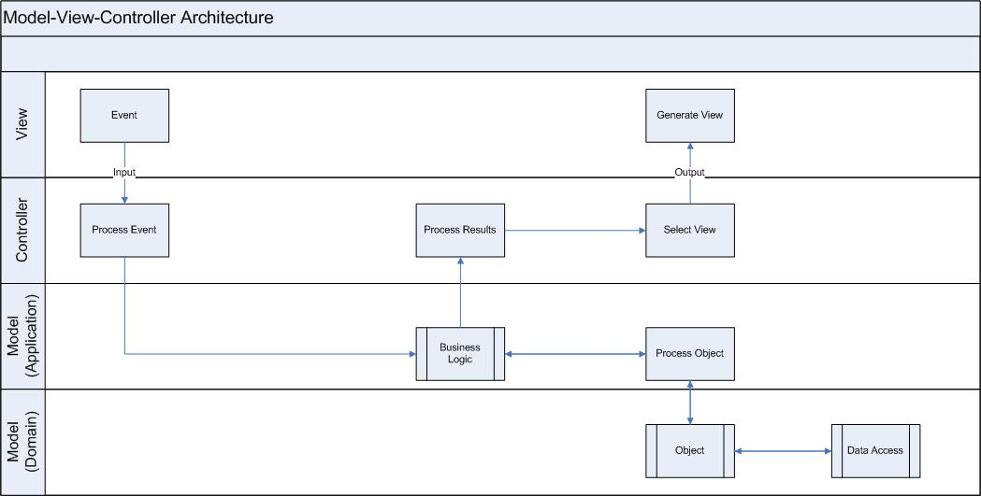

Figure 1: MVC Architecture

**(http://www.w3schools.com/aspnet/mvc_intro.asp)**

**The Model** is the part of the application that handles the logic for the application data.  
Often model objects retrieve data (and store data) from a database.

**The View** is the parts of the application that handles the display of the data.  
Most often the views are created from the model data.

**The Controller** is the part of the application that handles user interaction.  
Typically controllers read data from a view, control user input, and send input data to the model.

## Component Diagram

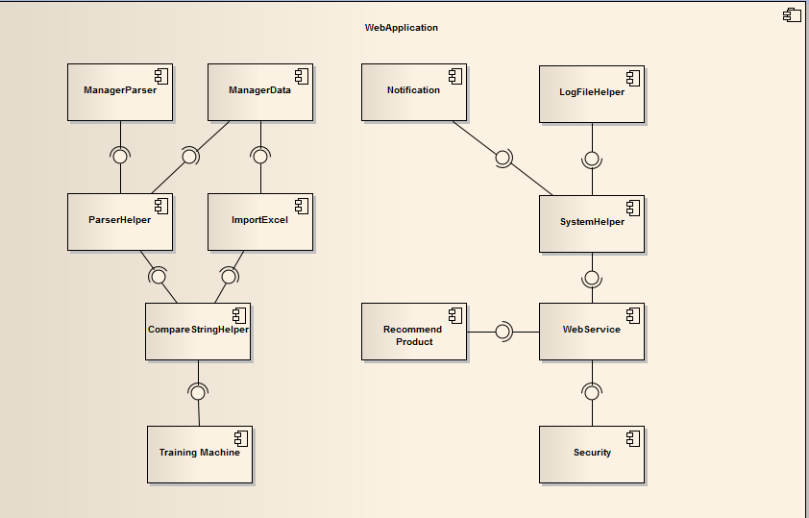

Figure 2: Component Diagram

## Detailed Description of Components

### Class Diagram

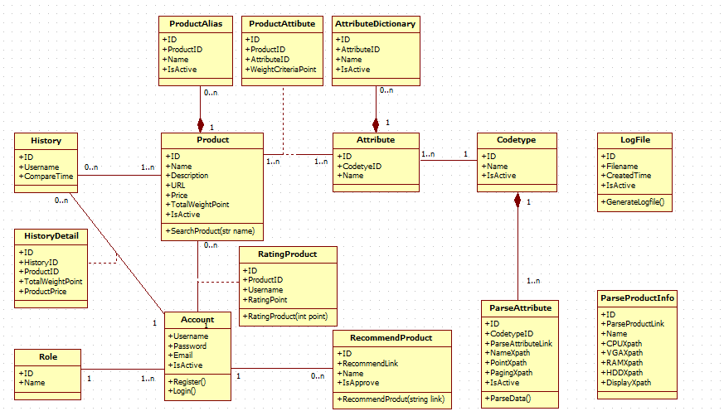

Figure 3: Class Diagram

### Class Diagram Explanation

#### Codetype

Attribute

|  |  |  |  |
| --- | --- | --- | --- |
| **Attribute** | **Type** | **Visibility** | **Description** |
| Id | Integer | Public | Unique identifier of each code type |
| Name | String | Public | Name of code type |
| IsActive | Boolean | Public | Status of code type |

#### ParseAttribute

Attribute

|  |  |  |  |
| --- | --- | --- | --- |
| **Attribute** | **Type** | **Visibility** | **Description** |
| Id | Integer | Public | Unique identifier of each item |
| CodetypeID | String | Public | Id of codetype |
| ParseAttributeLink | String | Public | Link used to parse |
| NameXpath | String | Public | Xpath to get the name of attribute |
| PointXpath | String | Public | Xpath to get the point of attribute |
| PagingXpath | String | Public | Xpath to get the paging |
| IsActive | Boolean | Public | Status of attribute |

Method

|  |  |  |  |
| --- | --- | --- | --- |
| **Method** | **Return type** | **Visibility** | **Description** |
| ParseData | Void | Public | Run parser to get data |

#### Attribute

Attribute

|  |  |  |  |
| --- | --- | --- | --- |
| **Attribute** | **Type** | **Visibility** | **Description** |
| Id | Integer | Public | Unique identifier of each item |
| CodetypeId | Integer | Public | Id of codetype |
| Name | String | Public | Name of attribute |

#### AttributeDictionary

Attribute

|  |  |  |  |
| --- | --- | --- | --- |
| **Attribute** | **Type** | **Visibility** | **Description** |
| Id | Integer | Public | Unique identifier of each product |
| AttributeID | Integer | Public | Id of attribute |
| Name | String | Public | Name of attribute |
| IsActive | Boolean | Public | Status of AttributeDictionnary |

#### Product

Attribute

|  |  |  |  |
| --- | --- | --- | --- |
| **Attribute** | **Type** | **Visibility** | **Description** |
| Id | Integer | Public | Unique identifier of each item |
| Name | String | Public | Name of product |
| Description | String | Public | Description of this product |
| URL | String | Public | URL of this product |
| Price | Double | Public | Price of product |
| TotalWeightPoint | Double | Public | Point of this product |
| IsActive | Boolean | Public | Status of product |

Method

|  |  |  |  |
| --- | --- | --- | --- |
| **Method** | **Return type** | **Visibility** | **Description** |
| Search Product | Product | Public | Search product in system |

#### Product Attribute

Attribute

|  |  |  |  |
| --- | --- | --- | --- |
| **Attribute** | **Type** | **Visibility** | **Description** |
| Id | Integer | Public | Unique identifier of each item |
| ProductID | Int | Public | Id of product |
| AttributeID | Int | Public | Id of attribute |
| WeightCriteriaPoint | Double | Public | Point of product |

#### ProductAlias

Attribute

|  |  |  |  |
| --- | --- | --- | --- |
| **Attribute** | **Type** | **Visibility** | **Description** |
| ID | Int | Public | Unique identifier of each item |
| ProductID | Int | Public | Id of product |
| Name | String | Public | Product name |
| IsActive | Boolean | Public | Status of this productalias |

Method

|  |  |  |  |
| --- | --- | --- | --- |
| **Method** | **Return type** | **Visibility** | **Description** |
| Register | Void | Public | For new user to register |
| Login | Boolean | Public | Used to log in the system |

#### History

Attribute

|  |  |  |  |
| --- | --- | --- | --- |
| **Attribute** | **Type** | **Visibility** | **Description** |
| Id | Integer | Public | Unique identifier of each history |
| Username | String | Public | Owner of this history |
| CompareTime | DateTime | Public | The time when owner compare product |

#### History Detail

Attribute

|  |  |  |  |
| --- | --- | --- | --- |
| **Attribute** | **Type** | **Visibility** | **Description** |
| Id | Integer | Public | Unique identifier of each item |
| HistoryId | Integer | Public | Id of history |
| ProductId | Integer | Public | Id of product |
| WeightCriteriaPoint | Integer | Public | Point of product |
| Price | Double | Public | Price of product |

#### Role

Attribute

|  |  |  |  |
| --- | --- | --- | --- |
| **Attribute** | **Type** | **Visibility** | **Description** |
| Id | Integer | Public | Unique identifier of each role |
| Name | String | Public | Role name |

#### Log File

Attribute

|  |  |  |  |
| --- | --- | --- | --- |
| **Attribute** | **Type** | **Visibility** | **Description** |
| Id | Integer | Public | Unique identifier of each file |
| FileName | String | Public | File name |
| CreatedTime | DateTime | Public | The time when this file is created |
| IsActive | Boolean | Public | Status of this file |

Method

|  |  |  |  |
| --- | --- | --- | --- |
| **Method** | **Return type** | **Visibility** | **Description** |
| GenerateLogFile | Boolean | Public | Generate log file for each time system runs the parser |

#### Rating Product

Attribute

|  |  |  |  |
| --- | --- | --- | --- |
| **Attribute** | **Type** | **Visibility** | **Description** |
| Id | Integer | Public | Unique id of each item |
| Username | String | Public | The name of the user |
| ProductId | Integer | Public | The identifier of that product |
| Point | Integer | Public | Rating point of each product |

|  |  |  |  |
| --- | --- | --- | --- |
| **Method** | **Return type** | **Visibility** | **Description** |
| RatingProduct | Void | Public | rating price for the system |

#### Recommend Product

|  |  |  |  |
| --- | --- | --- | --- |
| **Attribute** | **Type** | **Visibility** | **Description** |
| Id | Integer | Public | Unique id of each item |
| Username | String | Public | The name of the user |
| RecommendLink | String | Public | Link that user recommend |
| RecommendTime | Datetime | Public | Time that user recommend |
| IsApprove | Boolean | Public | Status of recommend product |

|  |  |  |  |
| --- | --- | --- | --- |
| **Method** | **Return type** | **Visibility** | **Description** |
| RecommendProduct | Void | Public | Recommend product for system |

#### Parse Product Info

|  |  |  |  |
| --- | --- | --- | --- |
| **Attribute** | **Type** | **Visibility** | **Description** |
| Id | Integer | Public | Unique id of each item |
| ParseProductLink | String | Public | Link to get parser |
| Name | String | Public | Name of this parser product info |
| CPUXpath | String | Public | Xpath to get the CPU |
| HDDXpath | String | Public | Xpath to get the HDD |
| VGAXpath | String | Public | Xpath to get the VGA |
| RAMXpath | String | Public | Xpath to get the RAM |
| DisplayXpath | String | Public | Xpath to get the Display |
| IsActive | String | Public | Status of parser |

#### Account

Attribute

|  |  |  |  |
| --- | --- | --- | --- |
| **Attribute** | **Type** | **Visibility** | **Description** |
| Username | String | Public | Unique username of each user |
| Password | String | Public | Password of user |
| Email | String | Public | Email of User |
| IsActive | String | Public | Status of account |

Method

|  |  |  |  |
| --- | --- | --- | --- |
| **Method** | **Return type** | **Visibility** | **Description** |
| Register | Boolean | Public | Register a new account in system |
| Login | Boolean | Public | Check if is existed account in system |

### Sequence Diagram

#### Parse Data

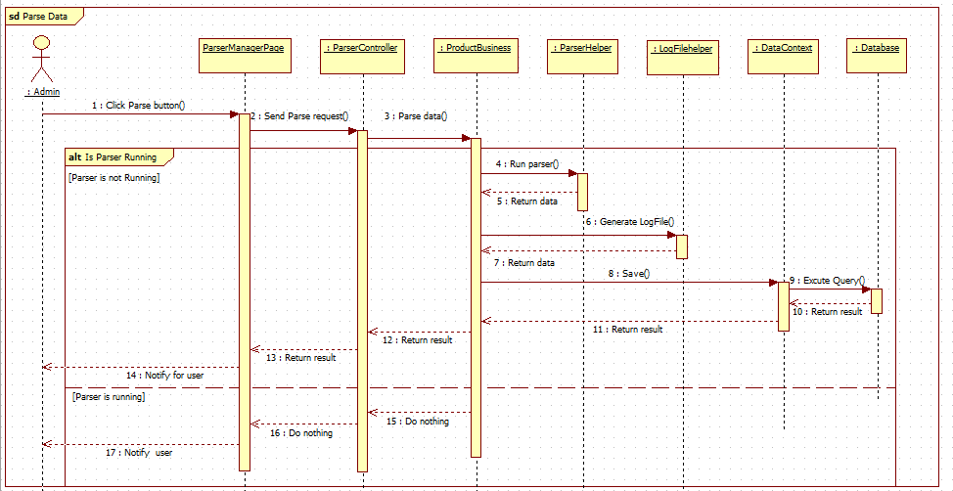

Figure 4: Parse Data Sequence Diagram

#### Import Excel

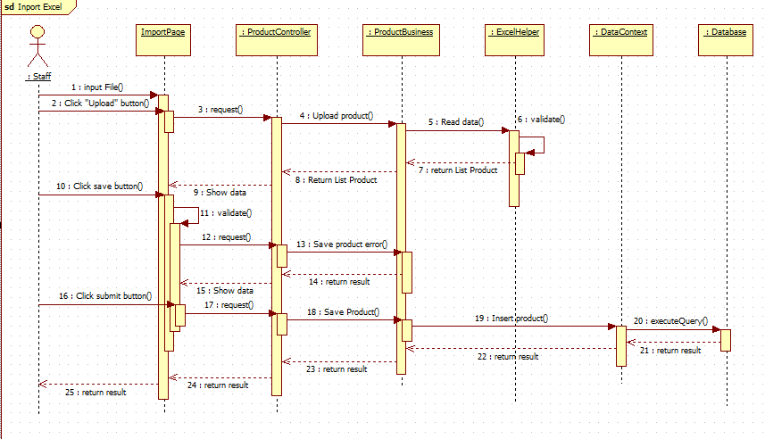

Figure 5: Import Excel Sequence Diagram

#### Recommend Product

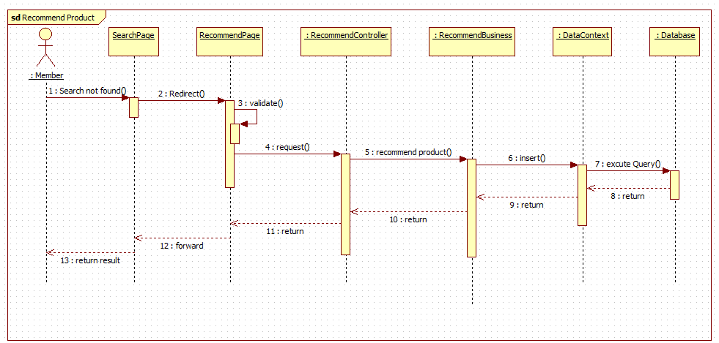

Figure 6: Propose Price Sequence Diagram

#### Save Product History

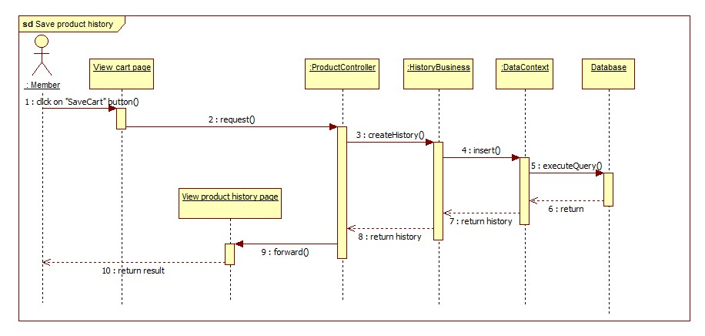

Figure 7: Save Product History Sequence Diagram

#### View Product History

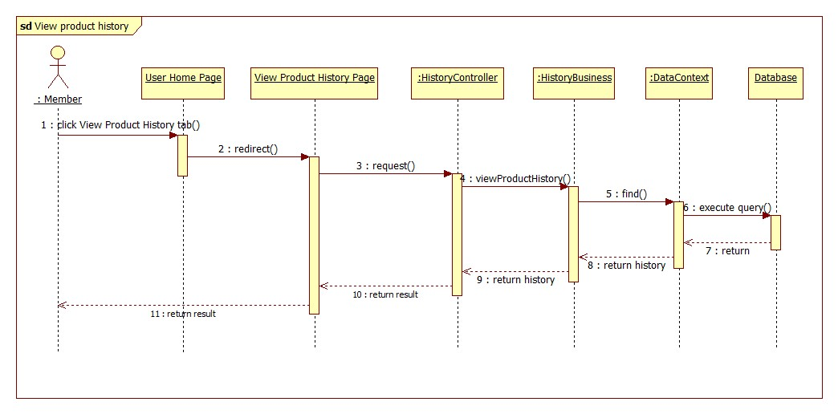

Figure 8: View Product History Sequence Diagram

#### View History Detail

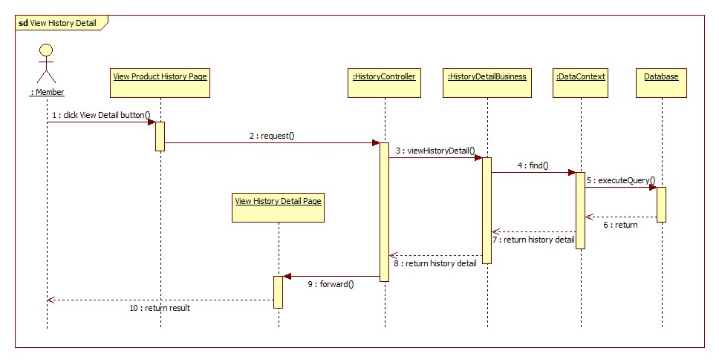

Figure 9: View History Detail Sequence Diagram

#### Configure System

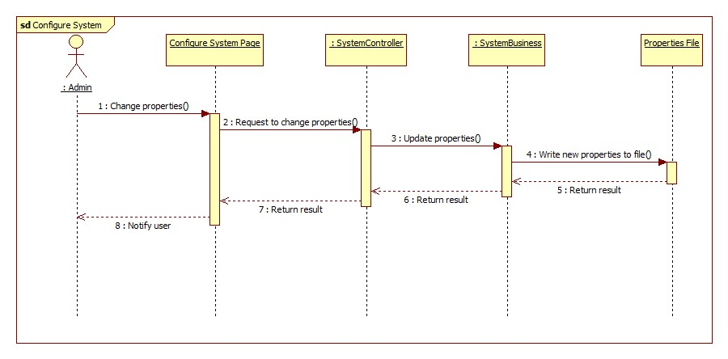

Figure 10: Configure System Sequence Diagram

## Database Design

### Logical Diagram

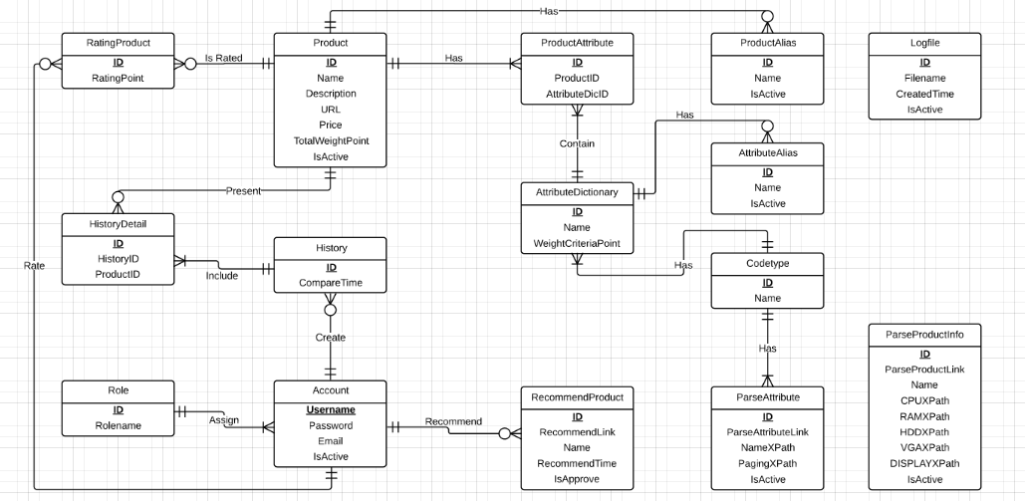

Figure 11: Logical Diagram

### Data Dictionary

|  |  |
| --- | --- |
| **Entity Data dictionary: describe content of all entities** | |
| **Entity Name** | **Description** |
| Codetype | Describe all codetype in the system. |
| ParseProductInfo | Describe all data needed to parse 1 specified product |
| Attribute | Describe all attributes of a product. |
| Product | Describe all products in the system. |
| ProductAttribute | Describe relationship between Attribute and Product. |
| ProductAlias | Describe all alias name of product in the system. |
| AttributeDictionary | Describe all possible Attribute names in the system. |
| Account | Describe all accounts in the system. Account includes: admin, staff, member, guest… |
| RecommendProduct | Describe the product that user recommend for system. |
| History | Describe all compare histories of user in the system. |
| HistoryDetail | Describe details of any history in the system. |
| Role | Describe all roles in the system. One user has only one role. |
| LogFile | Describe all log files of the system. |
| ParserAttribute | Describe all data needed to parse 1 websites to get attribute |
| RatingProduct | Describe relationship between Attribute and Product. |

Table 1: Entity Data Dictionary

Table 2: Attribute Data Dictionary

## Algorithms